Read from STDIN, Write to STDOUT

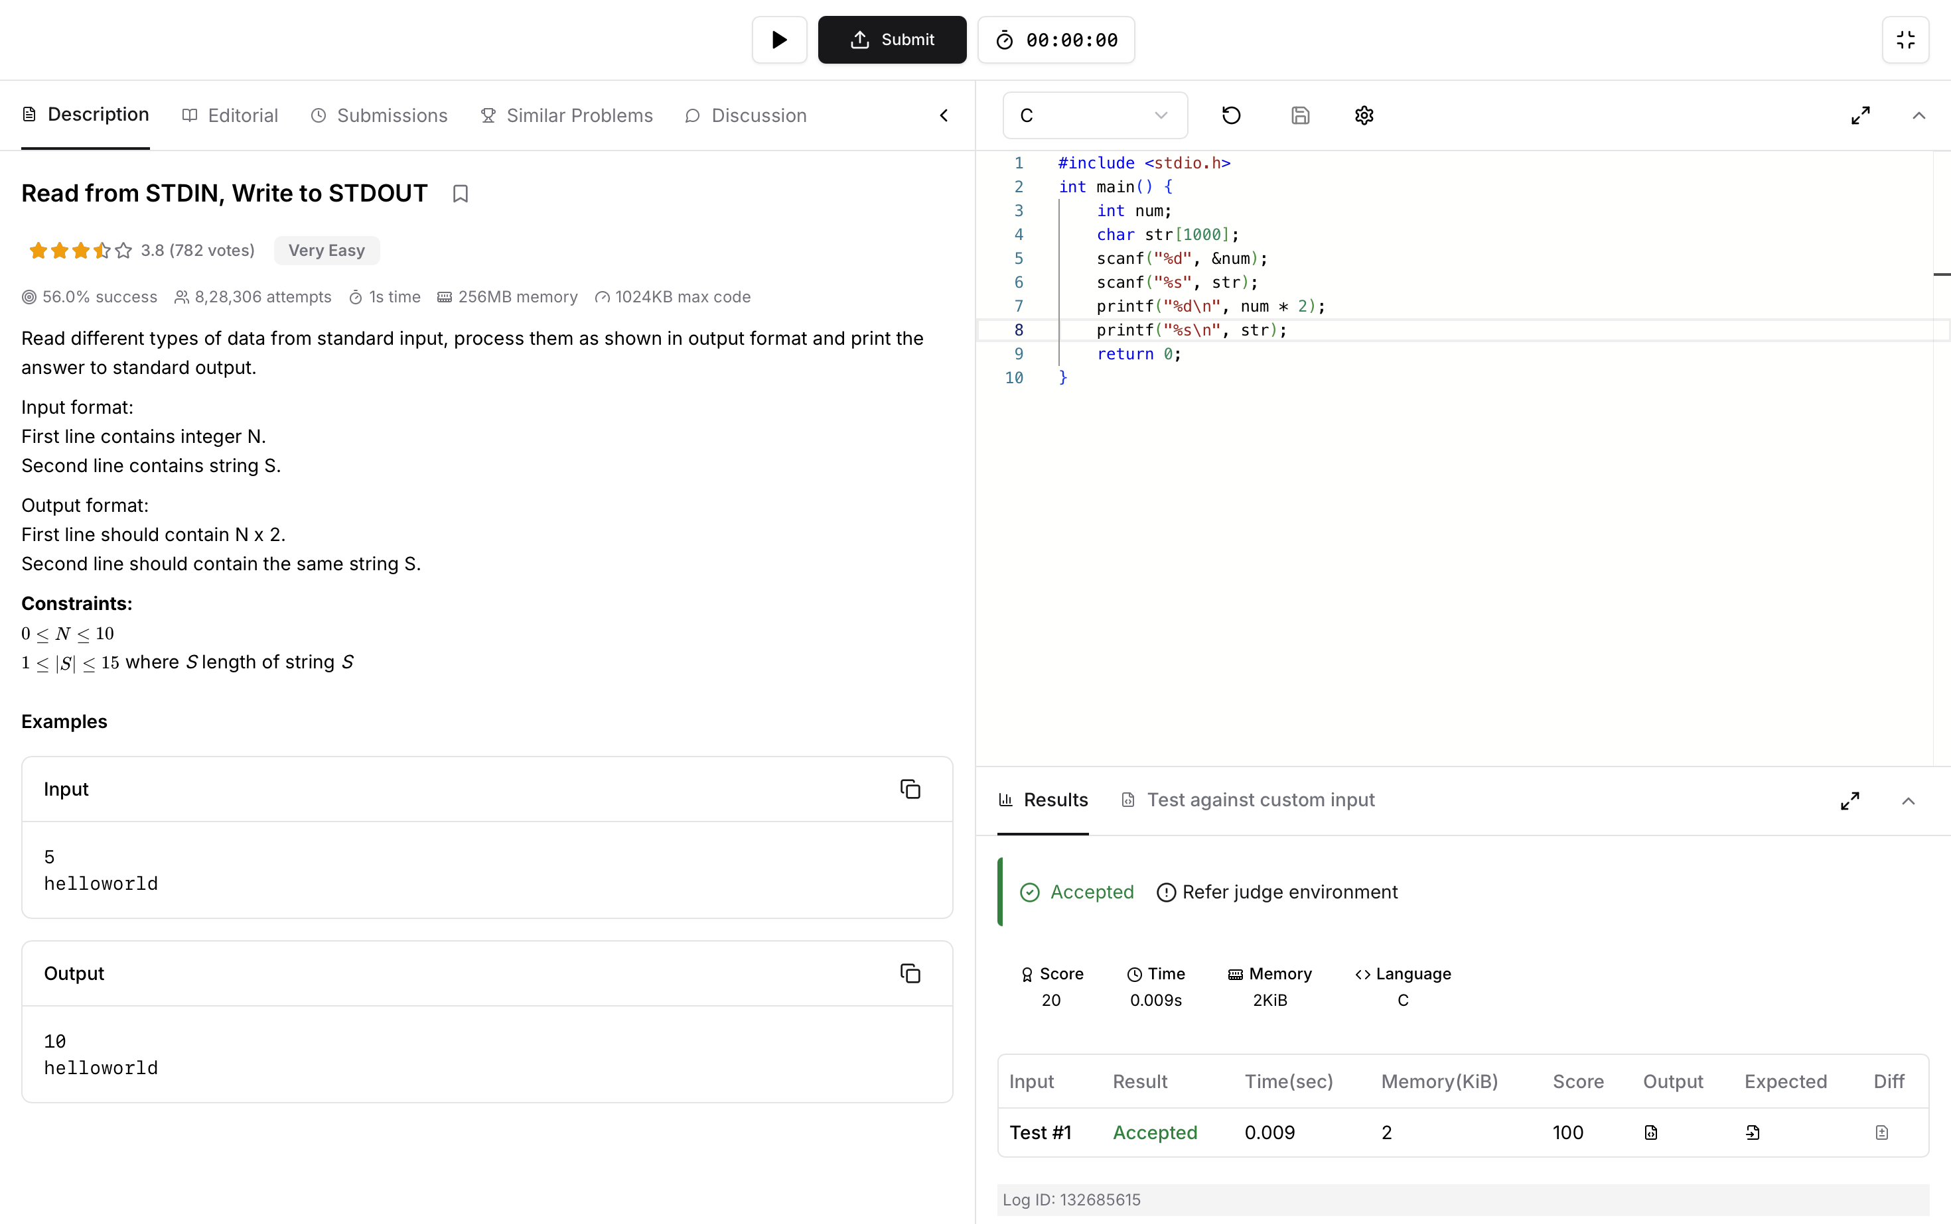
Code :
#include <stdio.h>
int main() {
int num;
char str[1000];
scanf("%d", &num);
scanf("%s", str);
printf("%d\n", num * 2);
printf("%s\n", str);
return 0;
}

